Brief Instructions for Flex Floor plan

When we install the plugin then we get the Flex floor plan menu in the left side .

Admin will click on the tab after that user can upload the svg from uploading option which is given in the below screenshot.

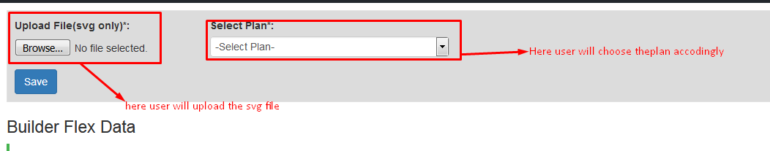

After choose the plan click on the submit button after that svg file is created same like as below screen-shot.  
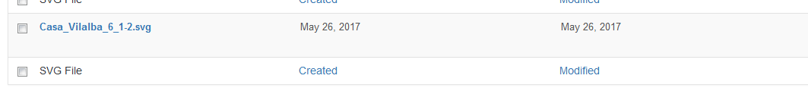

We can edit the svg file and also made changed according to them .  
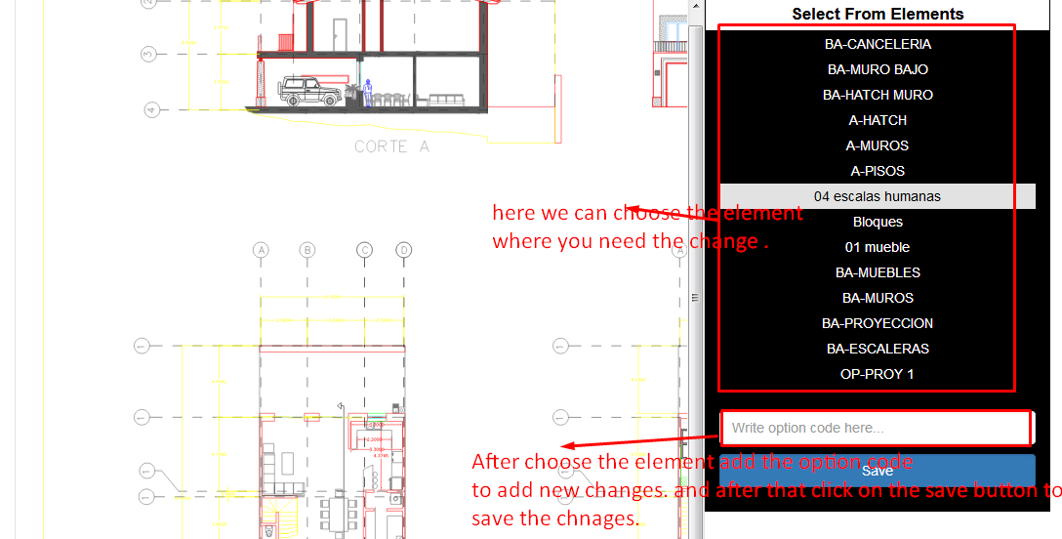

We are working on currently . Rest document we will provide asap .