How TO create Google map in BuilderUx Map Plug-in.

After installation the Builder UX , Plugin We need to go   
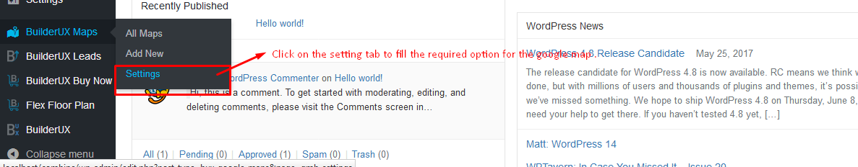

After click on we need to fill the Google Maps API Key and longitude and latitude and also fill the size of map .Then we need to click on the add new option to add the map with lots and overlay.

In the Admin Section , We need to click on the BuilderUX maps -> add new map option .

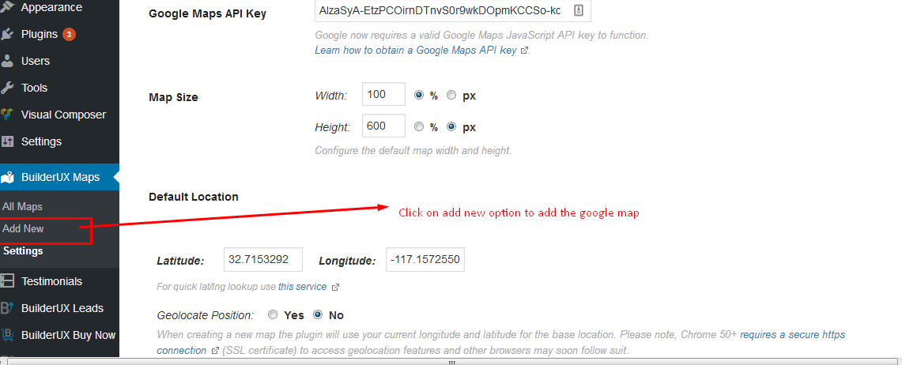

After click on the **add new** option , we need to add all the fields same like as below screenshot.

1. Add Title and Select Subdivisions in Google map

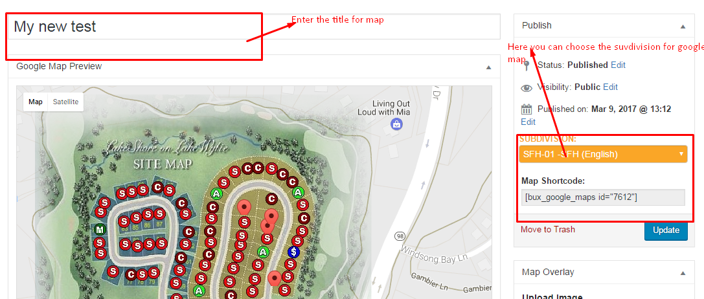

1. Add the Topo Screen and Lots In Google map

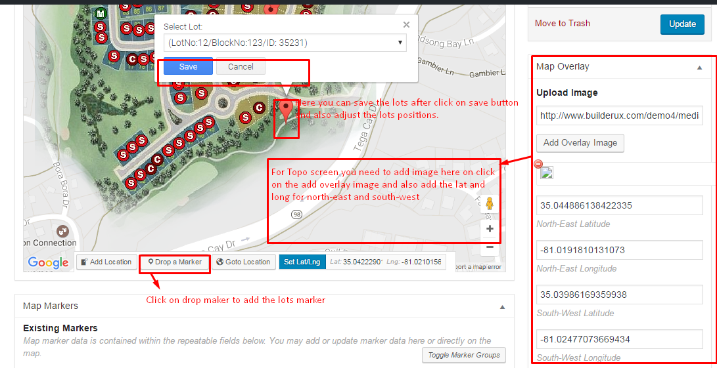

For overlay , if we want to add the lat and long then we can also use the drag option to find the exact location. When we drag the map to find the location for overlay then time to time **Set lat/Long is** changed. We will copy and paste into North-east and South -west lat and long.

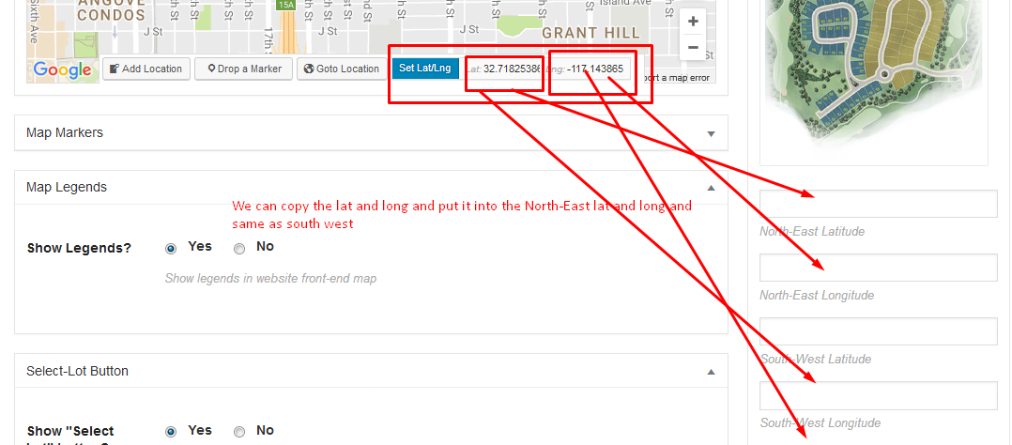

After that overlay will come on the map and we can add the lots on it .

1. If you want to edit the lot then click on same below lots and edit your lots and add the changes in it and In the Display option , we can also set the map according to our requirement.

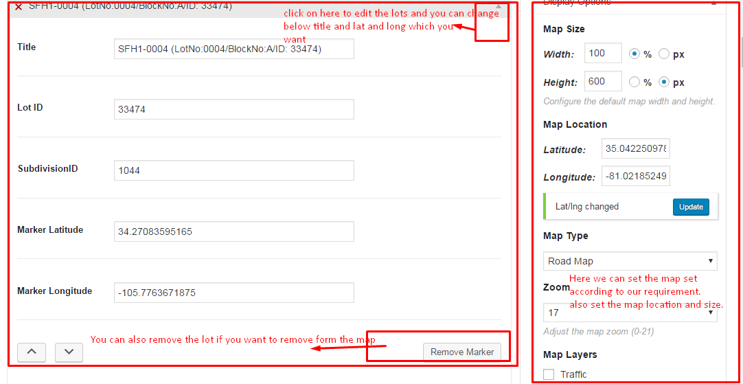

1. If you want to add some map legends then you can go to the below of the map and enable the option which you want to enable same like as below screenshot.  
     
   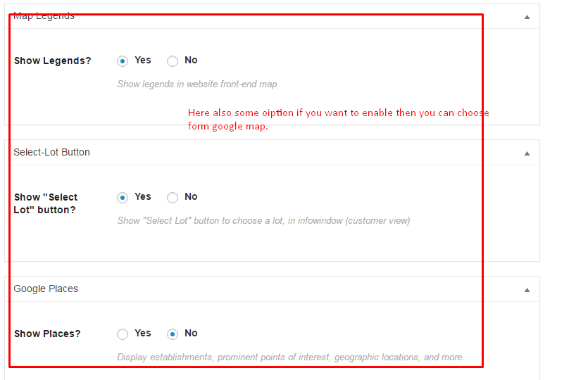
2. If you want to set the location then we can choose Goto location and we can also set map after frag and drop . Please review below screenshot .

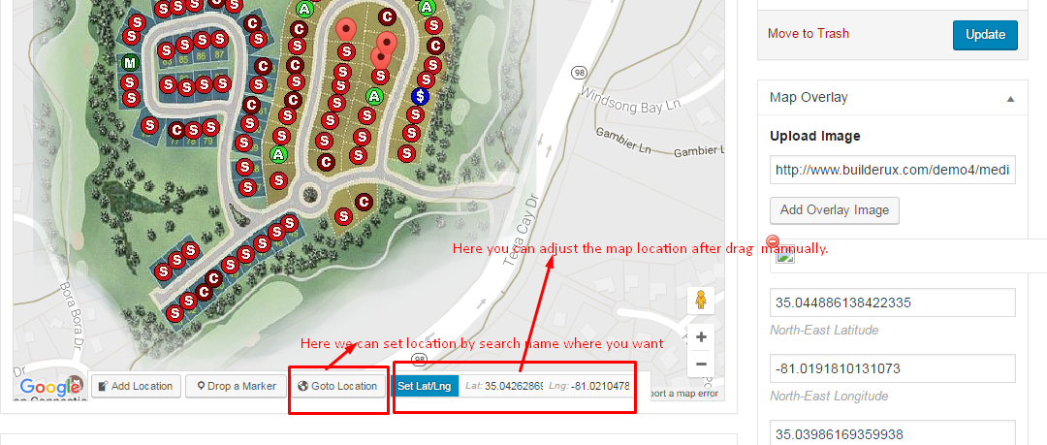  
After Added all the option we need to click on the **Publish** button to save the changes.

If we want to show the Google Map then we need to go to the BuilderUx plug-in Subdivision menu and after that open any subdivision and you can select the Google map option to show the Google map instead of image same like as below image.  
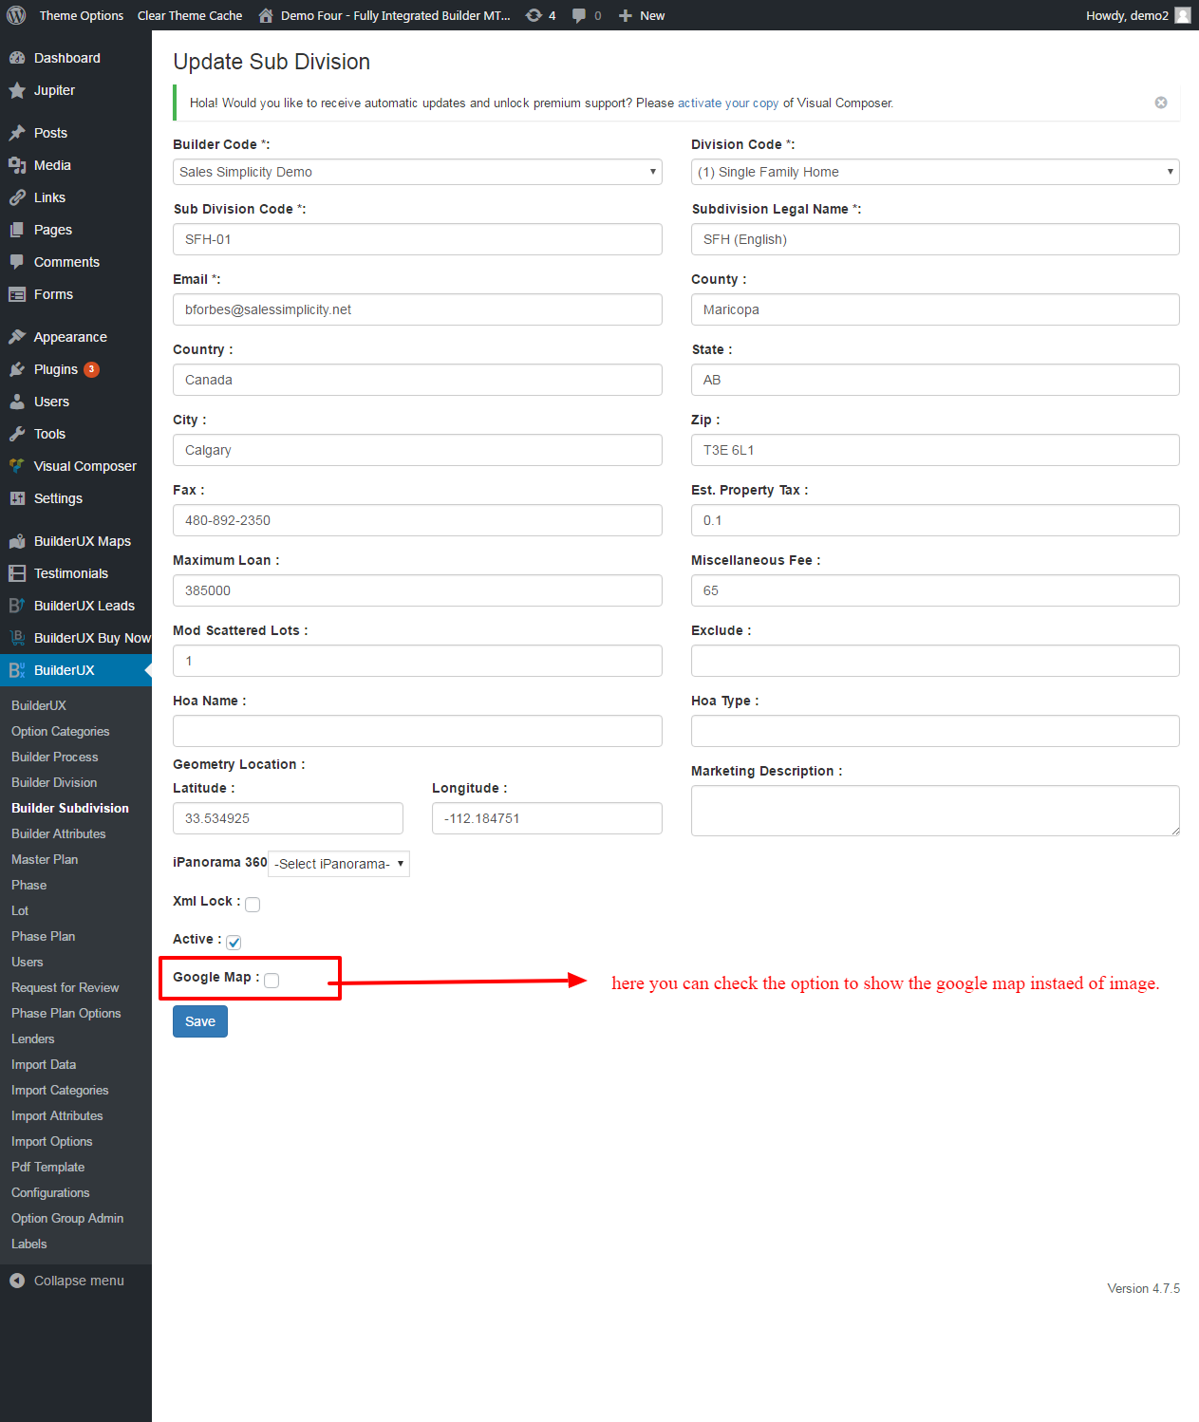

Please follow these steps for google map show instead of image in the builderUx plugin.